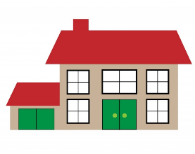
Family Emergency Plan

A home safety plan is for you to keep your family safe in case of emergency. This can be fire, natural disasters, floods
or another major event

Four parts of an emergency plan:

List family members

List emergency contact information

List emergency plan and meeting places

List medical problems/medical phone numbers

Family Emergency Plan:

List family members

____________________________________________________________________________________________________________________________________________________________________________________________________________________________________________________________________________________________________________________________________________________________________________________________________________________________________

List emergency contact information

______________________________________________________________________________________________________________________________________________________________________________________________________________________________________________________________________________________________________________________________________________________________

List emergency plan

______________________________________________________________________________________________________________________________________________________________________________________________________________________________________________________________________________________________________________________________________________________________

List emergency meeting places

______________________________________________________________________________________________________________________________________________________________________________________________________________________________________________________________________________________________________________________________________________________________

List medical problems/medical phone numbers
______________________________________________________________________________________________________________________________________________________________________________________________________________________________________________________________________________________________________________________________________________________________

Resource: Start a Home Safety Plan
www.ready.gov/plan

