Organizational Skills &
Time Management Handout

- The family has a problem

- Family needs to think about solutions and come up with a plan (set goals)

- Try to think of 3 solutions so you have more choices

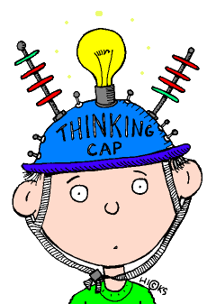

- Solutions checklist

Problem: ____________________________________________________________
Action plan (list 3 or more):
1.____________________________________________________________________
2.____________________________________________________________________
3.____________________________________________________________________

Problem: ____________________________________________________________
Action plan (list 3 or more):
1.____________________________________________________________________
2.____________________________________________________________________
3.____________________________________________________________________

Problem: ____________________________________________________________
Action plan (list 3 or more):
1.____________________________________________________________________
2.____________________________________________________________________
3.____________________________________________________________________

